Requirement Analysis – Data Flow Diagram & User Stories
Implement Client Script & UI Policy (Incident)

Date | 29 September 2026
Team ID | 6ab27553ba33564c8ba14e60
Project Name | Implement Client Script & UI Policy - Incident (ServiceNow)

Data Flow
User → Incident Form/List → Client-side controls → Incident record. Impact changes trigger UI Policy/onChange behavior. Submit triggers onSubmit validation. List State editing triggers onCellEdit validation. Valid actions are saved; invalid actions are rejected.

User Stories
User Type | Epic | ID | User Story | Acceptance Criteria | Priority | Release
Incident Agent | High Impact Control | US-01 | As an agent, I want Assignment group mandatory for High Impact. | Assignment group is mandatory at Impact = 1. | High | Sprint-1
Incident Agent | Urgency Automation | US-02 | As an agent, I want Urgency set to High automatically. | Urgency becomes High. | High | Sprint-1
Incident Agent | Urgency Protection | US-03 | As an agent, I want Urgency protected for High Impact. | Urgency is read-only. | High | Sprint-1
Incident Agent | Save Validation | US-04 | As an agent, I should not save High Impact without Assigned To. | Save is blocked with error. | High | Sprint-1
Incident Agent | List Protection | US-05 | As an agent, I should not change State from a list. | Alert appears and callback(false) blocks change. | Medium | Sprint-1
Incident Agent | Reverse Condition | US-06 | As an agent, I want normal behavior after leaving High Impact. | Mandatory/read-only changes reverse. | Medium | Sprint-1
Incident Agent | Form Update | US-07 | As an agent, I want State form updates to work. | Form update saves. | Medium | Sprint-1
Template Screenshots & Reference Links
The following visuals and links are retained from the supplied project template. They are included as reference material; actual ServiceNow screenshots should be added where the submission requires proof of the implemented configuration.

Template Reference Screenshots / Visuals

Data_Flow_Diagram_and_User_Stories_template_media_1.png
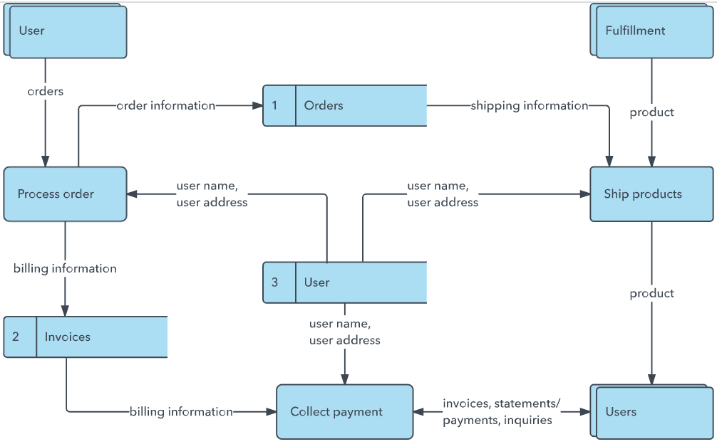
Data_Flow_Diagram_and_User_Stories_template_media_2.png
Data_Flow_Diagram_and_User_Stories_template_media_3.png
Data_Flow_Diagram_and_User_Stories_template_media_4.png

Reference Links
https://developer.ibm.com/patterns/visualize-unstructured-text/

